7-1 Final Design Decisions
Kyle Gortych
Southern New Hampshire University
CS 330: Computer Graphics and Visualization
Professor Kaan Esendemir
February 22, 2026
Justify development choices for your 3D scene. Think about why you chose your selected objects. Also consider how you were able to program for the required functionality.

The shapes I chose based on the scene reflect the requirements based on differences in material textures, colors, and geometry. In choosing hubcaps as the decorations on the wall and lamps over the booths both use chrome texture. The booths use a different texture and are colored red. For the objects on the tables the mustard and ketchup are colored red and yellow and the napkin dispenser uses metal and white for the napkins.

Placing objects in the scene and keeping track was easy as each object was similar in structure. By putting the objects together in a section it remains easy to see and identify along with refactoring. Using cones and cylinders for the ketchup and mustard bottles is just one example of combining two shapes to form one without having to make more objects.
Figure 1
Screenshot of diner (Davis, 2019)
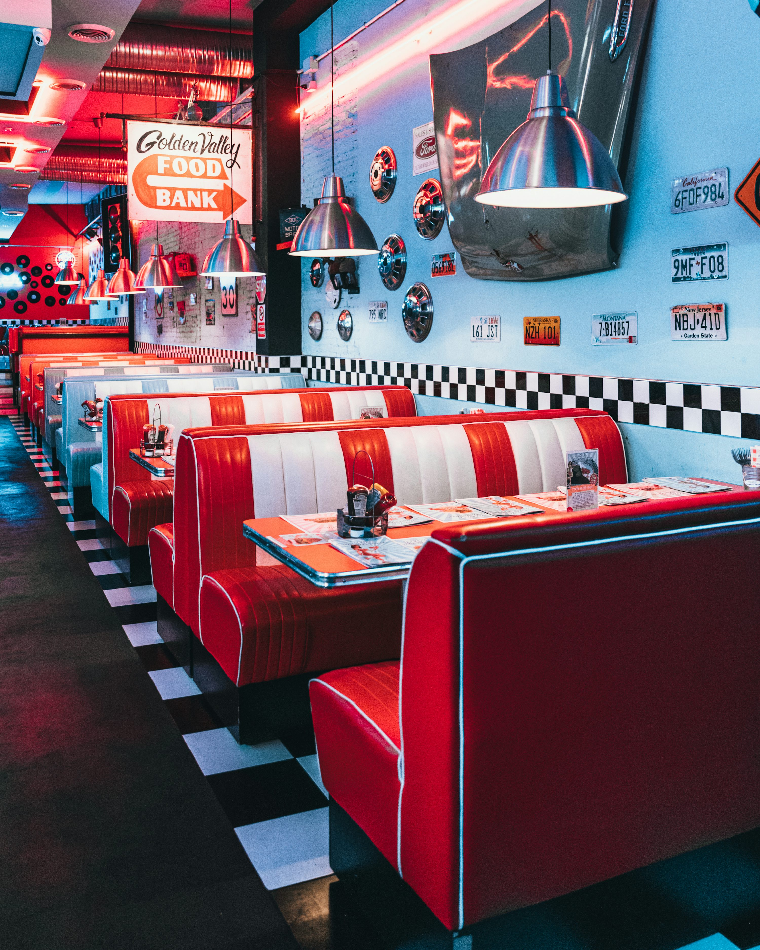
Note. Image downloaded from Unsplash. (2026).
Explain how a user can navigate your 3D scene. Explain how you set up to control the virtual camera for your 3D scene using different input devices.
A user can navigate the 3d space via w for forward, a for left, s for backwards, d for right, q for down and e for up. To change the perspective the key o is used for orthographic view and p for perspective view.

Figure 1
Perspective view via pressing p key.
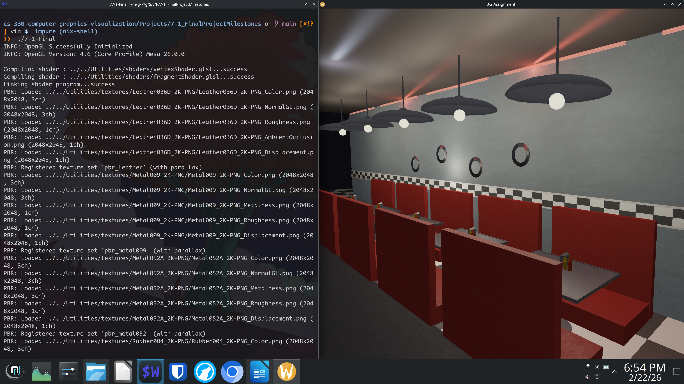
Note. Screenshot taken on host system (2026).
Figure 2
Orthographic view via pressing o key.
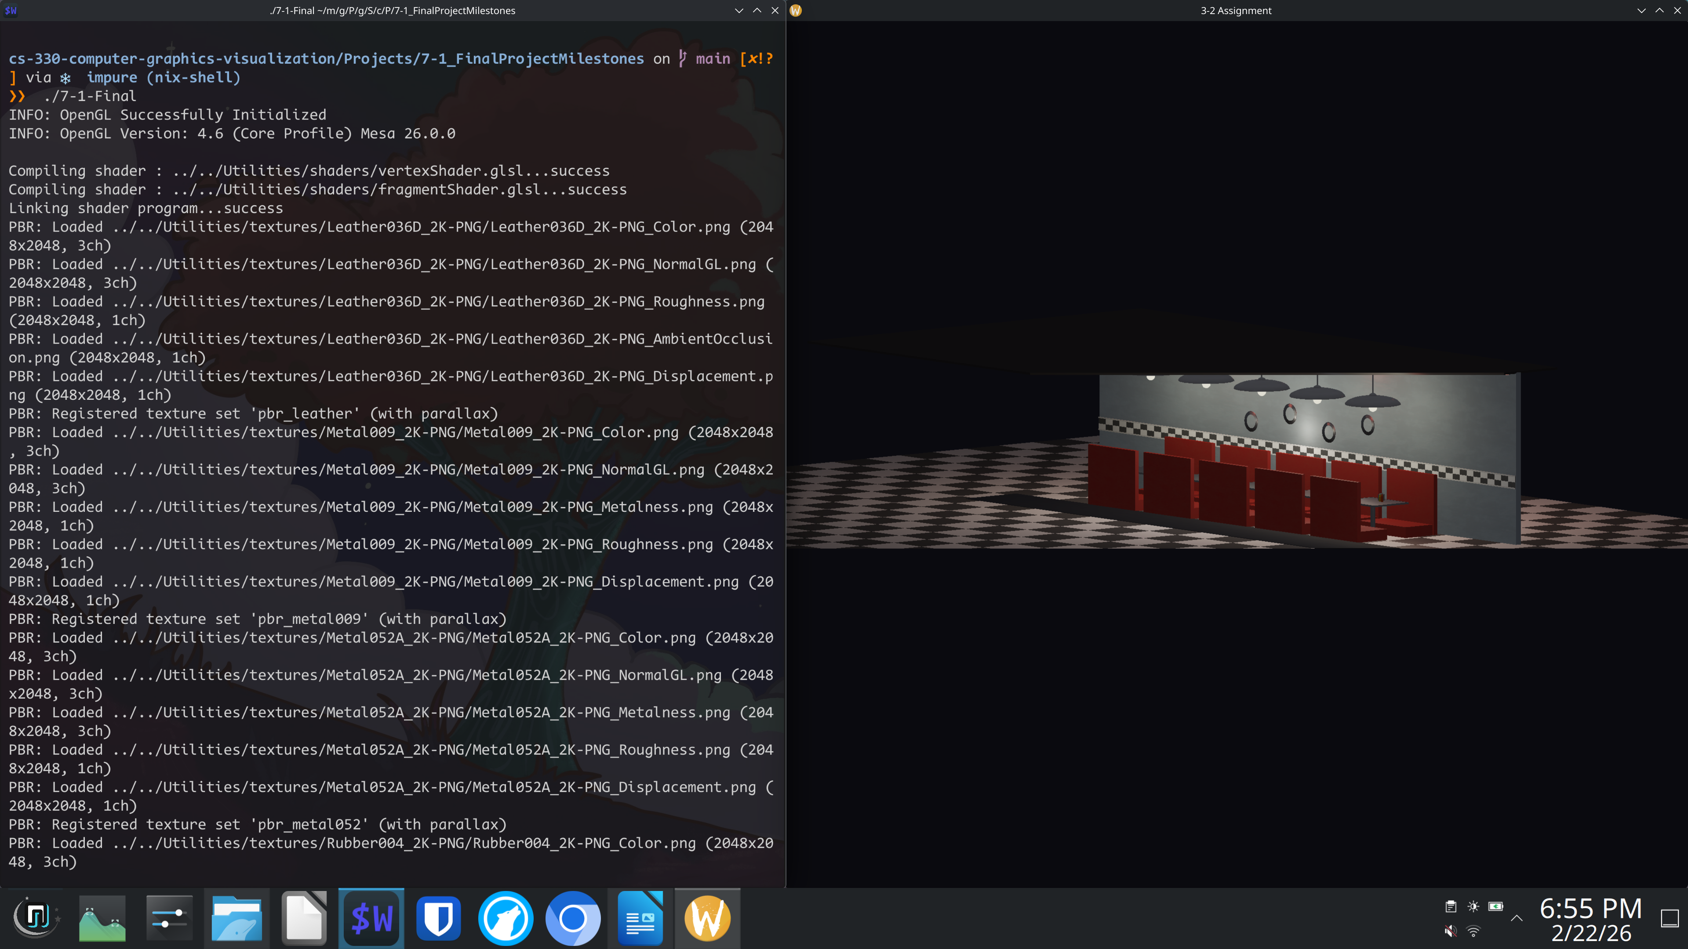
Note. Screenshot taken on host system (2026).
Explain the custom functions in your program that you are using to make your code more modular and organized. Ask yourself, what does the function you developed do and how is it reusable?
The custom functions in my SceneManager program are designed to keep the code modular, organized, and easier to maintain. Instead of placing all rendering logic directly inside RenderScene, I separated responsibilities into smaller helper functions that each handle a specific task, such as texture management, shader configuration, lighting setup, transformations, or camera control. This separation of concerns makes the program easier to read, debug, and expand.
The texture management system improves organization by isolating all texture-related operations into dedicated functions. CreateGLTexture loads an image, generates an OpenGL texture, configures its parameters, and stores it with a tag for easy reference. BindGLTextures and DestroyGLTextures handle binding and cleanup, while FindTextureSlot retrieves textures by name. This prevents repeated OpenGL setup code and makes it easy to add or manage textures without modifying rendering logic.
The PBR material system further strengthens modularity. LoadSingleTexture loads individual texture maps, CreateDefaultTexture provides fallback textures, and LoadPBRTextureSet groups multiple maps into a complete material. Because materials are registered with tags, I can apply them anywhere in the scene using a single call. This makes the material system reusable and scalable.
Example from my scene:
I use LoadPBRTextureSet to register materials like leather and metal, then apply them to booths and tables with SetShaderPBR, without rewriting texture binding code each time.
500 // Leather — diner booth seats
501 LoadPBRTextureSet("pbr_leather",
502 "../../Utilities/textures/Leather036D_2K-PNG/Leather036D_2K-PNG_Color.png",
503 "../../Utilities/textures/Leather036D_2K-PNG/Leather036D_2K-PNG_NormalGL.png",
504 nullptr,
505 "../../Utilities/textures/Leather036D_2K-PNG/Leather036D_2K-PNG_Roughness.png",
506 "../../Utilities/textures/Leather036D_2K-PNG/Leather036D_2K-PNG_AmbientOcclusion.png",
507 "../../Utilities/textures/Leather036D_2K-PNG/Leather036D_2K-PNG_Displacement.png");
508
509 // Applying the leather material to a booth back
510 SetTransformations(
511 glm::vec3(backThickness, backHeight, boothWidth),
512 0.0f, 0.0f, 0.0f,
513 glm::vec3(wallBackX, backY, zPos));
514 SetShaderPBR("pbr_leather");
515 SetUVScale(1.0f, 2.0f);
516 m_basicMeshes->DrawBoxMesh();

The shader helper functions keep rendering modular and ordered. Functions like SetShaderTexture, SetShaderColor, SetShaderPBR, SetShaderPBRTinted, SetShaderEmissive, and SetShaderCheckerboard configure the shader for a specific rendering mode while disabling others. This helps to prevents state conflicts and reduces repetitive setup. The function names describe the intended visual result making the scene easier to understand.
The SetupLighting function centralizes all lighting values in one place. It defines light positions, colors, and intensities and sends them to the shader. This allows me to adjust the total shading and color of the entire diner scene by editing a single function rather than searching through the rendering code.
The SetTransformations function groups all scaling, rotation, and translation into one reusable block. Every object uses this function before being drawn, which keeps RenderScene focused on scene layout rather than matrix operations. This greatly reduces repetition and improves readability.
Example from my scene:
Before drawing each booth component, table, or lamp, I call SetTransformations to position and scale it correctly, ensuring consistent transformation logic across the entire scene.
597 // FLOOR black & white checkerboard
598 SetTransformations(
599 glm::vec3(20.0f, 1.0f, 30.0f),
600 0.0f, 0.0f, 0.0f,
601 glm::vec3(0.0f, 0.0f, 0.0f));
602 SetShaderCheckerboard(
603 20.0f, 30.0f,
604 glm::vec3(0.92f, 0.92f, 0.92f),
605 glm::vec3(0.06f, 0.06f, 0.06f));
606 m_basicMeshes->DrawPlaneMesh();
607
608 // RUBBER AISLE STRIP center walkway PBR rubber on top of floor
609 SetTransformations(
610 glm::vec3(3.0f, 0.02f, 30.0f),
611 0.0f, 0.0f, 0.0f,
612 glm::vec3(1.0f, 0.01f, 0.0f));
613 SetShaderPBR("pbr_rubber");
614 SetUVScale(2.0f, 10.0f);
615 m_basicMeshes->DrawBoxMesh();

Overall, these functions improve modularity by grouping repeated logic and clearly defining responsibilities via comments. Each function performs a single purpose and can be reused throughout the project, making the code more maintainable and easier to extend.
References

Davis, S. (2019, April 23). red padded sofa and tables inside building [Photograph]. Unsplash.com; Unsplash. https://unsplash.com/photos/red-padded-sofa-and-tables-inside-building-o_XkavUaGEw

